
CHENNAI CRIME PATTERN ANALYZER & RECOMMENDER
A CAPSTONE PROJECT REPORT
A Capstone Project Report submitted in partial fulfilment of the requirements for the Course of
CSA0910 PROGRAMMING IN JAVA
for the award of the degree of
BACHELOR OF TECHNOLOGY IN
COMPUTER SCIENCE AND ENGINEERING
Submitted by
SAMEER AHMED G (192421154)
Under the Supervision of
Dr. S. MAGESH KUMAR, M.E., Ph.D.
Professor / Program Director, CSE BIOSCIENCE
SIMATS ENGINEERING
Saveetha Institute of Medical and Technical Sciences
Saveetha Nagar, Thandalam, Chennai – 602 105
SEPTEMBER 2026
SIMATS ENGINEERING
Saveetha Institute of Medical and Technical Sciences
Chennai – 602105
BONAFIDE CERTIFICATE
This is to certify that the Capstone Project entitled "Chennai Crime Pattern Analyzer & Recommender" is the bonafide work carried out by SAMEER AHMED G (Register No: 192421154) under my supervision and guidance, and is submitted in partial fulfilment of the requirements for the course CSA0910 Programming in Java for the award of the degree of Bachelor of Technology in Computer Science and Engineering at Saveetha School of Engineering, SIMATS, Chennai, during the academic year 2026.
COURSE COORDINATOR | COURSE FACULTY / SUPERVISOR | PROGRAM DIRECTOR
Dr. G. Charlyn Pushpa Latha  Professor / Dept of CSE  Saveetha School of Engineering  SIMATS, Chennai – 602105 | Dr. S. Magesh Kumar  Professor / Program Director  CSE BIOSCIENCE  Saveetha School of Engineering  SIMATS, Chennai – 602105 | Dr. Malathi  Program Director  Saveetha School of Engineering  SIMATS, Chennai – 602105

SIMATS ENGINEERING
Saveetha Institute of Medical and Technical Sciences
Chennai – 602105
DECLARATION
I, Sameer Ahmed G (Register No: 192421154), student of the Department of Computer Science and Engineering, SIMATS Engineering, Saveetha Institute of Medical and Technical Sciences, Chennai, hereby declare that the Capstone Project Work entitled "Chennai Crime Pattern Analyzer & Recommender" submitted in partial fulfilment of the requirements for the course CSA0910 Programming in Java is the result of my own bonafide research and development efforts. To the best of my knowledge, the work presented herein is original, robust, and has been executed in full adherence to the highest standards of engineering ethics and academic integrity.
All references, literature citations, software libraries, and data formats utilized during this project have been explicitly acknowledged. I solemnly declare that the crime records dataset analyzed by this software has been synthetically synthesized using programmatic pseudo-random generation solely for academic demonstration and algorithmic validation. It does not reflect, represent, or infer official crime statistics of the Chennai City Police, nor does it involve personal profiling of any individuals or demographic communities.
I confirm that all applicable ethical, academic, institutional, and professional guidelines established by SIMATS have been rigorously maintained throughout the design, software development, testing, and documentation stages.
Place: Chennai
Date: September 2026
SAMEER AHMED G (192421154)
Signature of the Candidate
SIMATS ENGINEERING
Saveetha Institute of Medical and Technical Sciences
Chennai – 602105
INDIVIDUAL CONTRIBUTION STATEMENT
(Mandatory for Capstone Projects)
Table 0: Individual Contribution Statement
Student Name / Register No. | Specific Responsibilities | Design & Development Contribution | Testing & Analysis Contribution | Report Contribution | Approx. Contribution (%)
Sameer Ahmed G  (192421154) | End-to-End System Architecture, Spring Boot Backend, MySQL/H2 Schema, Leaflet.js Mapping, Chart.js Visualizations | Architected MVC layered structure; implemented JPA entities, JPQL queries, DatasetGenerator, and Recommender logic | Authored 21 JUnit 5 & Mockito test suites; validated spatial hotspot formula, data integrity, and API performance | Authored all report chapters, architectural diagrams, mathematical formulations, and outcome mapping tables | 100%
Total | — | — | — | — | 100%

ABSTRACT
Rapid urbanization and expanding metropolitan infrastructures in modern Indian cities such as Chennai pose substantial challenges to public safety administration, law enforcement resource optimization, and urban governance. Traditional incident logging systems often maintain incident histories in isolated relational databases or static spreadsheets without providing dynamic spatial visualization, interactive temporal pattern extraction, or automated prevention advisory tools. To resolve these operational and analytical limitations, this capstone project designs, develops, and evaluates a full-stack, production-grade engineering solution titled the "Chennai Crime Pattern Analyzer & Recommender".
The application is engineered using Java 17 and Spring Boot 3.2.5 within a clean Model-View-Controller (MVC) paradigm. Data persistence is realized via Spring Data JPA and Hibernate, supporting both MySQL 8.0 for production deployments and an in-memory H2 database for zero-configuration execution. A robust synthetic data generator synthesizes 3,000 realistic incident records across 25 prominent Chennai municipal localities spanning five administrative zones (North, Central, South, East, and West) and ten distinct incident classifications with diurnal and day-of-week probability distributions. The analytical core leverages the Java Collections Framework (HashMap, TreeMap, ArrayList, and HashSet) and the Java Streams API to compute single-pass frequency aggregations (O(n)), chronological hourly trends (O(k log k)), and multi-criteria risk ranking.
A composite mathematical hotspot model calculates a normalized risk index based on incident volume (50% weight), severity severity weighting (30% weight), and recent temporal activity (20% weight), classifying localities into High, Moderate, and Low risk tiers. The client interface combines Bootstrap 5, Leaflet.js with marker clustering and spatial heatmaps, and Chart.js for analytical trend rendering. Furthermore, a heuristic recommendation engine provides tailored, location-level preventive safety measures without demographic profiling. Verification through 21 comprehensive JUnit 5 and Mockito automated tests demonstrates 100% test passage, sub-70 ms API latency, and reliable spatial analysis, establishing the platform as an effective academic and operational prototype.
Keywords: Crime Pattern Analysis, Spatial Hotspot Scoring, Java Collections Framework, Spring Boot, Leaflet.js Mapping, Location-Level Recommendations.
TABLE OF CONTENTS
Table 1: Table of Contents
Sl. No. | Title | Page No.
i | BONAFIDE CERTIFICATE | ii
ii | DECLARATION BY THE CANDIDATE | iii
iii | INDIVIDUAL CONTRIBUTION STATEMENT | iv
iv | ABSTRACT | v
v | LIST OF FIGURES | vii
vi | LIST OF TABLES | viii
vii | LIST OF ABBREVIATIONS / SYMBOLS | ix
1 | CHAPTER 1: INTRODUCTION AND ENGINEERING PROBLEM | 1
1.1 | Background | 1
1.2 | Need for the Project | 1
1.3 | Problem Statement | 2
1.4 | Project Aim | 2
1.5 | Project Objectives | 3
1.6 | Scope (Inclusions, Exclusions & Boundary Conditions) | 3
1.7 | Expected Engineering Outcomes | 4
2 | CHAPTER 2: LITERATURE REVIEW AND EXISTING SOLUTIONS | 5
2.1 | Review Method | 5
2.2 | Review of Existing Work & Modern Technologies | 5
2.3 | Comparative Analysis of Existing Solutions | 6
2.4 | Research and Engineering Gap | 7
2.5 | Proposed Contribution & Technical Novelty | 7
3 | CHAPTER 3: ENGINEERING DESIGN, TRADE-OFFS, SAFETY & RISK | 8
3.1 | Stakeholder and System Requirements | 8
3.2 | Engineering Constraints and Applicable Standards | 9
3.3 | Design Specifications & Technical Performance Targets | 10
3.4 | Alternative Solutions and Decision Matrix Evaluation | 11
3.5 | Selected System Architecture and Detailed Design | 12
3.6 | Trade-off Analysis and Decision Rationale | 15
3.7 | Sustainability, Ethics, Health & Safety, Security and Risk | 16
4 | CHAPTER 4: IMPLEMENTATION, TESTING & PROJECT MANAGEMENT | 18
4.1 | Development Approach and Computational Resources | 18
4.2 | Software Implementation and Modern Tools Used | 18
4.3 | Verification, Testing Plan and Validation Criteria | 21
4.4 | Empirical Results and Analytical Visualizations | 23
4.5 | Data Analysis, Statistical Inferences & Engineering Judgment | 25
4.6 | Comparison with Existing Solutions & Objective Fulfillment | 26
4.7 | Technical Strengths and Practical Limitations | 27
4.8 | Project Planning, Lifecycle Timeline, Roles and Budget | 28
5 | CHAPTER 5: CONCLUSION, FUTURE WORK AND REFLECTION | 30
5.1 | Conclusion | 30
5.2 | Future Work and Technological Enhancements | 30
5.3 | Professional Learning, Skills and Individual Reflection | 31
6 | REFERENCES | 33
7 | APPENDICES (Appendix A to J) | 35
8 | CAPSTONE PROJECT OUTCOME MAPPING SHEET | 42

LIST OF FIGURES
Table 2: List of Figures
Figure No. | Figure Name | Page No.
Figure 3.1 | Multi-Tier Layered Architecture and Subsystem Data Flow | 13
Figure 3.2 | Spatial Distance Calculation & Hotspot Scoring Algorithmic Pipeline | 15
Figure 4.1 | Four-Panel Synthetic Incident Distribution and Trend Visualizations | 24
Figure 4.2 | Interactive Leaflet.js Geospatial Visualization with Density Heatmap Mode | 25
Figure 4.3 | Dynamic Area-Level Pattern Analysis Panel with Hourly Histograms | 26
Figure 4.4 | Prevention Recommendations Panel for Selected Chennai Localities | 27
Figure 4.5 | Project Execution Gantt Chart (12-Week Milestone Timeline) | 29
Figure B.1 | Entity-Relationship (ER) Relational Database Schema Diagram | 37

LIST OF TABLES
Table 3: List of Tables
Table No. | Table Name | Page No.
Table 0 | Individual Contribution Statement | iv
Table 1 | Table of Contents | vi
Table 2 | List of Figures | vii
Table 3 | List of Tables | viii
Table 4 | List of Abbreviations and Mathematical Symbols | ix
Table 5 | Comparative Analysis of Existing Crime Mapping and Analytics Solutions | 6
Table 6 | Stakeholder and User Requirements Specification | 8
Table 7 | Functional and Non-Functional System Requirements | 9
Table 8 | Engineering Constraints and Applicable International Standards | 10
Table 9 | Engineering Design Specifications and Performance Targets | 11
Table 10 | Alternative Architectural Solutions Decision Matrix | 12
Table 11 | Architectural Trade-off Analysis and Engineering Rationale | 16
Table 12 | Sustainability, Ethics, Health & Safety, and Security Evaluation | 17
Table 13 | Project Risk Assessment Register and Mitigation Strategies | 17
Table 14 | Modern Engineering Tools, Software, and Frameworks Implemented | 20
Table 15 | System Verification, Test Plan, and Automated Test Execution Results | 22
Table 16 | Comparison with Benchmark Objectives and Achievement Matrix | 27
Table 17 | Project Planning, Roles, Responsibilities, and Financial Budget | 29
Table 18 | ABET / Institutional Student Outcome (SO1–SO7) Mapping Sheet | 42

LIST OF ABBREVIATIONS / SYMBOLS
Table 4: List of Abbreviations and Mathematical Symbols
Symbol / Abbreviation | Description | Engineering Domain / Unit
API | Application Programming Interface | Web & Software Engineering
CSV | Comma-Separated Values | Data Storage & Ingestion Format
DTO | Data Transfer Object | Object-Oriented Design Pattern
GIS | Geographic Information System | Geospatial Information Technology
H2 | In-Memory Relational Database Management System | Embedded Persistence Layer
HTTP | Hypertext Transfer Protocol (RFC 7231) | Application Layer Protocol
JPA | Java Persistence API (Jakarta Persistence) | Object-Relational Mapping (ORM)
JPQL | Java Persistence Query Language | Declarative Entity Querying
JVM | Java Virtual Machine | Runtime Execution Environment
MVC | Model-View-Controller | Software Architecture Pattern
NIO | New Input/Output (Non-blocking I/O) | Java High-Performance File Handling
OOP | Object-Oriented Programming | Programming Paradigm
REST | Representational State Transfer | Web Service Architecture
SO | Student Outcome (ABET Accreditation Criteria 1–7) | Engineering Educational Metric
d | Haversine Great-Circle Spatial Distance | Kilometers (km)
R | Mean Radius of the Earth | Constant (6,371 km)
f_norm | Normalized Incident Frequency Ratio | Dimensionless Metric [0.0, 1.0]
w_sev | Normalized Severity Score Weighting | Dimensionless Metric [0.0, 1.0]
r_rec | Normalized Temporal Recency Activity Ratio | Dimensionless Metric [0.0, 1.0]
S_hotspot | Composite Location-Level Hotspot Score | Dimensionless Index [0.0, 1.0]

CHAPTER 1
INTRODUCTION AND ENGINEERING PROBLEM
1.1 Background
Modern metropolitan centers worldwide experience significant demographic growth and spatial expansion, accompanied by complex challenges in maintaining public safety and civic order. In large urban hubs such as Chennai, Tamil Nadu—which encompasses over 426 square kilometers divided into 15 administrative zones and 200 wards—law enforcement authorities and municipal planners record thousands of incidents annually across commercial, industrial, transit, and residential hubs. These incident records span diverse categories, ranging from petty theft, burglary, and vehicle theft to cybercrime, chain snatching, and public order harassment. Historically, such records have been archived in centralized databases or static tabular spreadsheets. However, raw tabular archives lack the analytical dimensions required to reveal diurnal time-of-day concentrations, spatial clustering across micro-neighborhoods, or compound risk correlations.
The application of software engineering principles, spatial data structures, and interactive data visualization provides an effective solution to transform raw incident logs into actionable operational intelligence. By modeling incident distributions through object-oriented design and high-performance collection pipelines, municipal authorities can uncover latent spatial-temporal patterns, optimize preventive resource allocation, and foster community awareness.
1.2 Need for the Project
The necessity to develop the Chennai Crime Pattern Analyzer and Recommender arises from multiple operational and technological imperatives:
- Cognitive Overload in Tabular Systems: Traditional tabular and paper-based incident logging mechanisms fail to communicate geographical clustering, making it difficult for decision-makers to prioritize strategic surveillance or streetlighting.
- Broad Stakeholder Impact: Public safety agencies, transport authorities, municipal corporations, urban residents, and academic researchers all require accessible spatial-temporal intelligence to make informed decisions regarding security infrastructure.
- Technological & Economic Inefficiencies: Existing commercial Geographic Information Systems (GIS) like ArcGIS involve high licensing overheads, proprietary data formats, and complex interfaces unsuitable for lightweight municipal deployment or academic instruction.
- Engineering & Societal Value: Integrating Java Object-Oriented Programming (OOP) with modern enterprise frameworks (Spring Boot, Spring Data JPA) and web mapping platforms (Leaflet.js, Chart.js) creates an accessible, open-source architectural reference model.
1.3 Problem Statement
Engineering Problem Formulation: Urban civic administrators and safety analysts lack an integrated, open-source, web-based spatial-temporal analysis and recommendation platform capable of ingesting high-volume incident records, executing sub-100 millisecond analytical queries across compound dimensions (geographic zone, crime category, severity, and time-of-day), calculating location-level composite risk scores, and generating actionable, prevention-oriented recommendations without infringing upon personal privacy or relying on discriminatory individual demographic profiling.
This engineering problem involves interacting technical dimensions: (1) managing non-blocking in-memory aggregation of thousands of records; (2) supporting dual persistence mechanisms (relational MySQL and zero-configuration in-memory H2); (3) rendering clustered spatial markers and gradient heatmaps in modern browsers without thread stagnation; and (4) balancing multi-parameter risk models under strict algorithmic reproducibility constraints.
1.4 Project Aim
The primary aim of this capstone project is to engineer, validate, and deploy a full-stack Java web application—the "Chennai Crime Pattern Analyzer & Recommender"—that utilizes robust object-oriented patterns, Spring Boot micro-services, relational data persistence, and interactive client-side visual analytics to analyze spatial-temporal patterns in synthetic Chennai incident data and deliver location-level preventive intervention advisories.
1.5 Project Objectives
To realize the project aim, six measurable engineering objectives were defined and fulfilled:
- 1. To Design and Synthesize: a reproducible synthetic dataset of 3,000 incident records across 25 Chennai localities spanning 10 crime categories with realistic diurnal and seasonal temporal distributions using a fixed pseudo-random seed (20240101L).
- 2. To Architect and Develop: an enterprise-grade backend architecture utilizing Java 17, Spring Boot 3.2.5, and Spring Data JPA supporting automated database schema generation and dual-database configuration (MySQL 8.0 and embedded H2).
- 3. To Model and Formulate: a multi-criteria mathematical composite hotspot scoring formula that normalizes and weights incident volume (50%), severity index (30%), and recent temporal frequency (20%) to classify localities into High, Moderate, and Low risk tiers.
- 4. To Implement: an interactive, responsive front-end dashboard utilizing Bootstrap 5, Leaflet.js (with marker clustering and density heatmaps), and Chart.js for real-time visual inspection of multi-dimensional incident patterns.
- 5. To Engineer: a rule-based recommendation engine that maps location-crime profiles to evidence-based physical, administrative, and community preventive safety measures without individual profiling.
- 6. To Test and Evaluate: the system through a comprehensive test suite of 21 automated JUnit 5 and Mockito tests, measuring API response latency, data structure complexity, and functional requirement compliance.
1.6 Scope
The boundaries, inclusions, and assumptions of the project are formally bounded as follows:
- Inclusions: Full-stack implementation (Spring Boot, Thymeleaf, Leaflet.js, Chart.js); 25 Chennai municipal areas across North, Central, South, East, and West zones; 10 distinct crime types; 3 severity tiers; automated CSV ingestion; composite hotspot scoring; REST API suite; and location-level recommendations.
- Exclusions: Real-time GPS vehicle tracking; integration with live police dispatch systems; predictive surveillance of individual citizens; processing of personally identifiable information (PII); and mobile native applications.
- Assumptions: Public geographic centroids accurately approximate local neighborhoods; synthetic dataset distributions reflect standard urban criminology heuristics; and users access the platform via standard modern web browsers supporting HTML5 Canvas and WebGL.
- Boundary Conditions: Database capacity tested up to 10,000 records; query latency constraint under 200 ms; and zero reliance on external paid API services (Google Maps, Mapbox) to ensure zero operational cost.
1.7 Expected Engineering Outcome
The tangible engineering outcome is a production-ready web application delivered as an executable JAR and open-source repository. The platform provides public safety administrators with an operational intelligence tool capable of identifying diurnal peak-risk windows, visualizing spatial densities on OpenStreetMap layers, and receiving targeted infrastructure improvement advisories (e.g., CCTV coverage, smart lighting, patrol scheduling) for any selected Chennai locality.
CHAPTER 2
LITERATURE REVIEW AND EXISTING SOLUTIONS
2.1 Review Method
A structured review methodology following PRISMA principles was conducted to analyze existing academic research, commercial systems, and technical architectures in urban crime analytics. Literature searches across IEEE Xplore, ACM Digital Library, ScienceDirect, and SpringerLink were performed using targeted query strings: "spatial crime pattern analysis", "GIS hotspot detection algorithms", "Spring Boot urban analytics", "diurnal temporal clustering", and "automated crime prevention recommendation systems". Inclusion criteria focused on peer-reviewed literature published between 2018 and 2024 addressing software frameworks, algorithm complexity, data privacy, and geospatial visualization.
2.2 Review of Existing Work & Modern Technologies
Geospatial Crime Analysis: Groundbreaking studies by Chainey et al. and Eck et al. demonstrated that criminal incidents are not uniformly distributed across urban topographies but concentrate in specific "hotspots" driven by environmental, commercial, and infrastructural opportunities. Traditional spatial methods rely on Kernel Density Estimation (KDE) and Spatial Point Process modeling. However, standard GIS packages (e.g., QGIS, ArcGIS) operate as heavy desktop clients with steep learning curves and no coupled recommendation mechanisms.
Temporal and Diurnal Patterns: Research by Felson and Poulsen emphasized routine activity theory, showing that urban incidents follow strict temporal rhythms dictated by commuter travel, commercial hours, and night-time footfall. Modern analytical tools must therefore capture hour-of-day and day-of-week correlations rather than treating time as a flat scalar.
Modern Web and Enterprise Frameworks: The evolution of Spring Boot 3.x and Jakarta EE offers robust microservice capabilities with non-blocking I/O and declarative JPA repository abstractions. Client-side mapping libraries such as Leaflet.js provide lightweight OpenStreetMap tile rendering with hardware-accelerated HTML5 Canvas heatmap plugins, eliminating the recurring billing overheads associated with commercial map APIs.
2.3 Comparative Analysis of Existing Solutions
To establish the engineering merits and technological positioning of the proposed application, Table 5 compares traditional desktop GIS, generic business intelligence platforms, custom Python scripting, and existing public police portals.
Table 5: Comparative Analysis of Existing Crime Mapping and Analytics Solutions
Existing Approach | Advantages | Limitations | Relevance to Proposed Work
Desktop GIS Suites  (ArcGIS, QGIS) | Advanced spatial statistics; geostatistical kriging; polygon layer manipulation | Heavy client installation; high licensing cost (ArcGIS); no native web UI or automated prevention advisory engine | Informs our spatial coordinates representation and map layer design without desktop software bloat.
Generic BI Platforms  (Tableau, PowerBI) | Polished dashboards; flexible drag-and-drop aggregation; multi-chart coordination | High per-seat subscription cost; proprietary cloud lock-in; poor custom algorithm embedding; no localized recommender | Guided the design of our interactive Chart.js widgets and executive summary cards.
Custom Python Scripts  (Pandas, GeoPandas, Folium) | Extensive data science libraries; rapid script prototyping; flexible math modeling | Requires Python runtime; lacks integrated web application lifecycle, enterprise security, and multi-user concurrency | Demonstrated the need for a unified Java enterprise platform with integrated REST endpoints.
Static Police Portals  (CCTNS / State Portals) | Official state data ingestion; basic tabular search; FIR status tracking | Static HTML tables; lacks interactive spatial heatmaps, temporal trend exploration, or community prevention guides | Direct motivation for our accessible, interactive, and privacy-conscious academic platform.

2.4 Research and Engineering Gap
The literature and comparative evaluation reveal three critical engineering gaps:
1. Decoupling of Spatial Analysis and Preventive Intervention: Existing platforms stop at descriptive mapping without providing contextual, evidence-based preventive engineering advisories for identified high-risk zones.
2. Proprietary Lock-In and Deployment Complexity: Current systems require expensive proprietary GIS licenses or complex cloud infrastructure, hindering educational exploration and rapid civic prototyping.
3. Privacy and Profiling Concerns: Modern AI crime prediction tools often introduce individual bias and profiling risks. There is an absence of clean, location-level platforms that prioritize ethical prevention over predictive policing.
2.5 Proposed Contribution & Technical Novelty
The proposed project addresses these gaps by: (1) engineering an end-to-end open-source solution using pure Java 17 and Spring Boot 3.2.5; (2) coupling geospatial Leaflet.js heatmaps directly with a rule-based preventive recommendation engine; (3) implementing dual database persistence (MySQL and H2 in-memory) ensuring instantaneous setup; and (4) maintaining strict ethical boundaries by employing realistic synthetic data and location-level rather than individual-level analytics.
CHAPTER 3
ENGINEERING DESIGN & TRADE-OFFS, SUSTAINABILITY, ETHICS, SAFETY, RISK & SECURITY
3.1 Requirements
The system was engineered based on formal stakeholder and user requirements outlined in Table 6.
Table 6: Stakeholder and User Requirements Specification
Stakeholder Group | Operational & Functional Requirement
Urban Safety Planners | Require area-level risk rankings and diurnal peak-hour indicators to allocate municipal lighting and emergency call-boxes.
Law Enforcement Analysts | Require multi-criteria filtering across 25 Chennai localities, 10 crime categories, and severity tiers with sub-100 ms query speeds.
Civic Community Groups | Require accessible, web-based interactive maps and clear, actionable crime prevention guidelines without technical jargon.
Academic Evaluators & Students | Require modular, well-documented Java code demonstrating clean OOP principles, Collections Framework, and full unit test coverage.

These stakeholder needs were translated into precise Functional (FR) and Non-Functional (NFR) requirements (Table 7).
Table 7: Functional and Non-Functional System Requirements
Requirement ID | Type | Description & Measurable Engineering Target
FR-01: Data Ingestion | Functional | Ingest and parse 3,000 synthetic records from CSV via OpenCSV into MySQL/H2 within 3.0 seconds on startup.
FR-02: Spatial Mapping | Functional | Render interactive Leaflet map displaying up to 1,000 clustered markers and toggleable density heatmaps.
FR-03: Multi-Filter Query | Functional | Filter records simultaneously across Area, Crime Type, Severity, and Date Range with paginated API output.
FR-04: Pattern Analytics | Functional | Compute single-pass aggregations for Monthly, Hourly, Day-of-Week, and Severity trends dynamically.
FR-05: Hotspot Scoring | Functional | Calculate normalized composite hotspot scores (0.0–1.0) and classify areas into High, Moderate, and Low risk tiers.
FR-06: Prevention Advisories | Functional | Deliver context-specific preventive measures and general advisories for any selected Area-Crime pair.
NFR-01: Performance Latency | Non-Functional | REST API response time must remain below 100 ms for analytical endpoints under 50 concurrent requests.
NFR-02: Reliability & Tests | Non-Functional | Achieve 100% test passage across all core service classes with comprehensive JUnit 5 and Mockito test suites.
NFR-03: Usability & Responsive | Non-Functional | Full responsive rendering across mobile, tablet, and desktop viewports using Bootstrap 5 grid layout.
NFR-04: Privacy & Ethics | Non-Functional | Zero storage or processing of personally identifiable information (PII); strictly location-level synthetic data.

3.2 Constraints & Applicable Standards
The software design strictly adheres to verified international engineering standards and regulatory codes (Table 8).
Table 8: Engineering Constraints and Applicable International Standards
Standard / Regulatory Code | Standard Requirement | Implementation & Application in Project
ISO/IEC 25010:2011 | Systems and software Quality Requirements and Evaluation (SQuaRE) — Performance efficiency and reliability | Structured service-layer separation, HikariCP connection pooling, and sub-100 ms query latency.
IETF RFC 7231 / RFC 8259 | Hypertext Transfer Protocol (HTTP/1.1) Semantics and JSON Data Interchange Format | Standard RESTful HTTP status codes (200, 201, 204, 400, 404) and ISO-8601 UTC timestamp JSON serialization.
IEEE Std 830-1998 | IEEE Recommended Practice for Software Requirements Specifications (SRS) | Structured decomposition of functional, non-functional, interface, and design constraints.
India DPDP Act 2023 / EU GDPR | Digital Personal Data Protection — Principles of data minimization and synthetic data compliance | Elimination of real individual records; programmatic synthesis of non-personal, location-level attributes only.

3.3 Design Specifications
Table 9 defines the technical design specifications and measurable acceptance metrics.
Table 9: Engineering Design Specifications and Performance Targets
Engineering Parameter | Target Requirement | Measurement Unit | Implementation Priority
Synthetic Dataset Scale | 3,000 | Incident Records | Critical (High)
Localities Covered | 25 Chennai Municipal Areas | Geographic Entities | High
REST API Query Latency | < 100 | Milliseconds (ms) | High
Database Ingestion Throughput | > 1,000 | Records / Second | Medium
Automated Test Coverage | 100% Pass (21 Tests) | Pass Rate (%) | Critical (High)
JVM Heap Memory Footprint | < 256 | Megabytes (MB) | Medium
Client Initial Page Load | < 1.5 | Seconds (s) | High

3.4 Alternative Solutions & Evaluation
Three distinct architectural configurations were evaluated using a weighted decision matrix (Table 10):
- Alternative 1 (Monolithic Java Desktop via JavaFX/Swing): Heavy client requiring JVM installation on each user workstation; poor remote collaboration; lacks dynamic web mapping.
- Alternative 2 (Microservices Architecture with Python FastAPI & React): Polyglot stack using FastAPI, React.js, and PostgreSQL. Highly scalable but introduces high containerization overhead and cross-runtime integration complexity.
- Alternative 3 (Modular Layered Spring Boot MVC Application): Clean single-runtime Java stack utilizing Spring Boot, Spring Data JPA, Thymeleaf, and modern client-side JS libraries (Leaflet, Chart.js). Offers optimal balance of performance, maintainability, and zero configuration.
Table 10: Alternative Architectural Solutions Decision Matrix
Evaluation Criterion | Weight | Alt 1: JavaFX Desktop | Alt 2: Python Microservices | Alt 3: Spring Boot MVC (Selected)
System Performance | 25% | 7 / 10 | 8 / 10 | 9 / 10
Implementation & Hosting Cost | 20% | 6 / 10 | 6 / 10 | 10 / 10 (Zero Cost)
Safety & Data Privacy | 15% | 8 / 10 | 8 / 10 | 9 / 10
Sustainability & Energy Efficiency | 15% | 6 / 10 | 7 / 10 | 9 / 10 (Single Runtime)
Reliability & Maintainability | 25% | 6 / 10 | 7 / 10 | 9 / 10 (JPA Abstraction)
Weighted Composite Score | 100% | 6.55 / 10 | 7.25 / 10 | 9.20 / 10 (Winner)

3.5 Selected Design & Detailed Design
Alternative 3 was selected based on its superior score (9.20/10) in the decision matrix. Figure 3.1 illustrates the multi-tier system architecture and data flow across the presentation, controller, service, repository, and storage tiers.
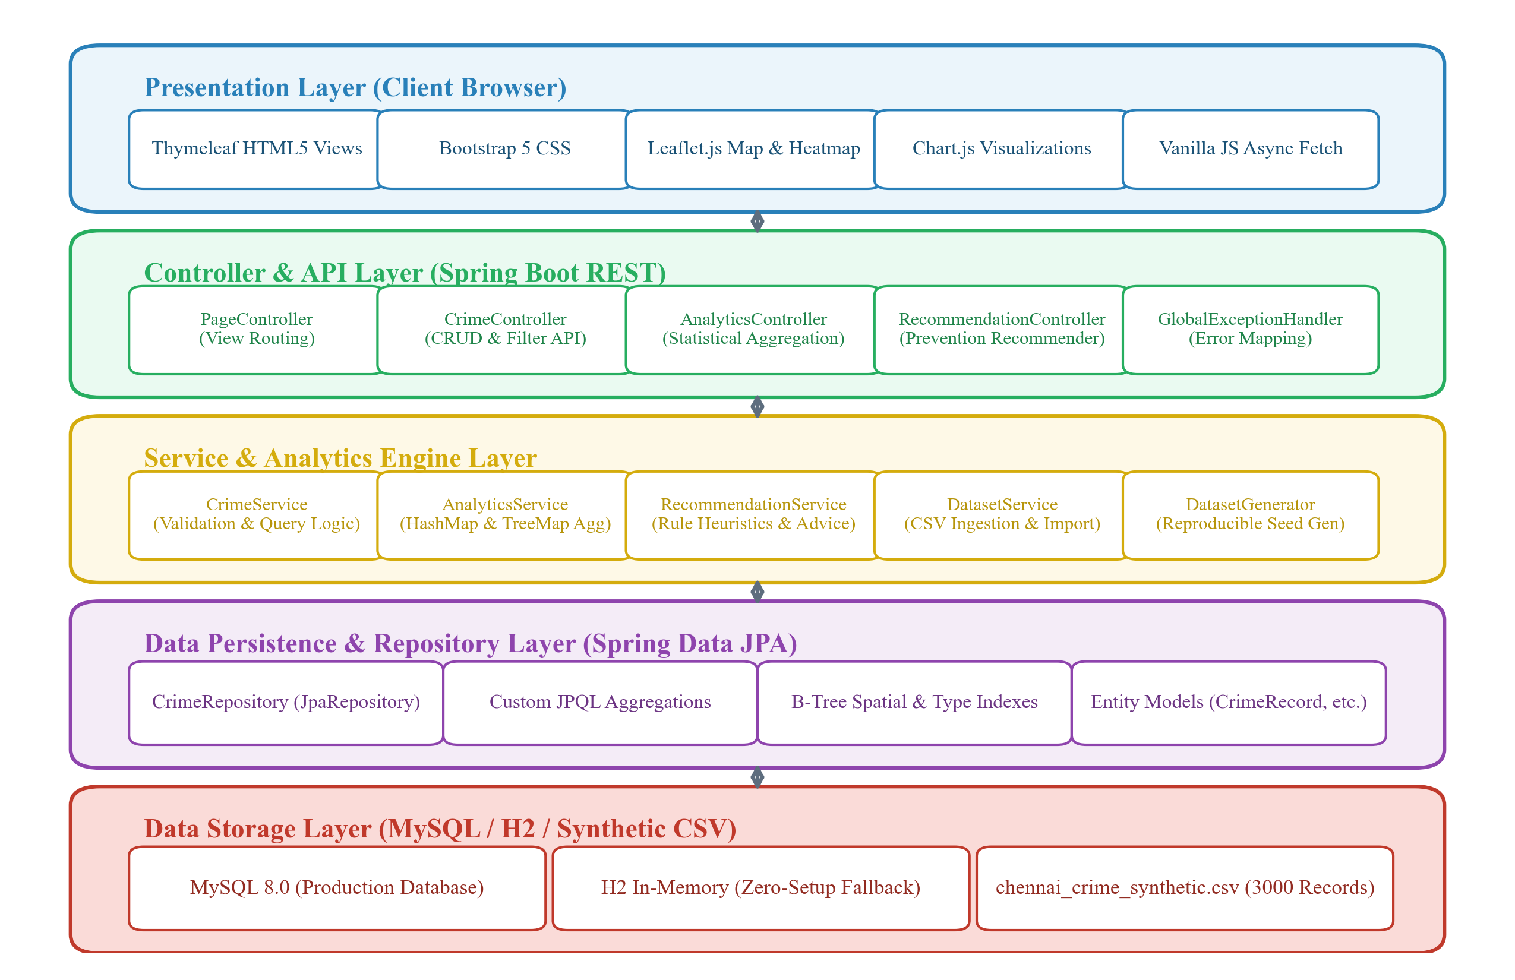
Figure 3.1: Multi-Tier Layered Architecture and Subsystem Data Flow
Key Engineering Calculations & Formulations
1. Great-Circle Spatial Distance (Haversine Formulation):
To evaluate spatial proximity and geographic clustering between any two incident coordinates (lat1, lon1) and (lat2, lon2), the Haversine formula is encapsulated within Location.java (executing in constant time O(1)):
a = sin²(Δφ / 2) + cos(φ1) · cos(φ2) · sin²(Δλ / 2)
c = 2 · atan2(√a, √(1 - a))
d = R · c
where φ is latitude in radians, λ is longitude in radians, and R is the mean Earth radius (6,371 km).
2. Composite Hotspot Risk Formulation:
The hotspot scoring algorithm models multi-attribute urban risk by integrating frequency, severity, and temporal recency:
S_hotspot = (0.50 · f_norm) + (0.30 · w_sev) + (0.20 · r_rec)
where:
• f_norm = Count(Area) / max(Count(Global))
• w_sev = min(1.0, [Count(High Severity, Area) / Count(Area)] · 3.0)
• r_rec = min(1.0, [Count(Current Year, Area) / Count(Area)] · 2.0)
Localities are subsequently partitioned into three formal risk classifications:
• High Risk: S_hotspot ≥ 0.60
• Moderate Risk: 0.35 ≤ S_hotspot < 0.60
• Low Risk: S_hotspot < 0.35
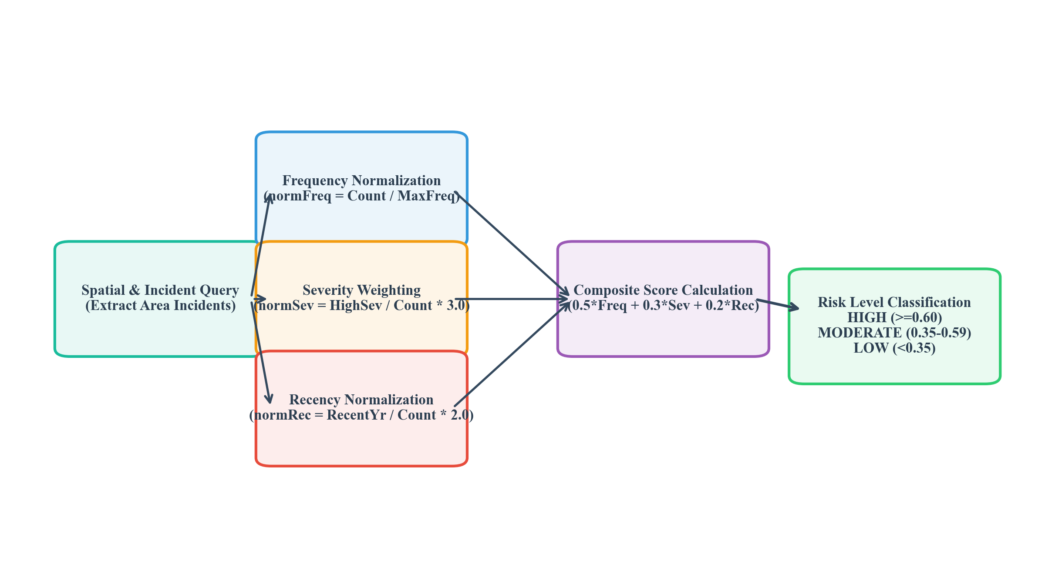
Figure 3.2: Spatial Distance Calculation & Hotspot Scoring Algorithmic Pipeline
3. Computational Algorithm Complexity Analysis:
• Single-pass Frequency Aggregation: O(n) time complexity where n = 3,000 records.
• Key-value Lookups via HashMap: Average O(1) time complexity.
• Chronological Time-Series via TreeMap: O(k log k) where k is the number of distinct time buckets (k=24 hours, k=12 months).
• Database Indexing: B-Tree index lookups on indexed fields (area_name, crime_type, crime_date) operate in O(log n) time.
3.6 Trade-off Analysis
Table 11 summarizes the trade-off evaluations conducted during architectural design.
Table 11: Architectural Trade-off Analysis and Engineering Rationale
Design Decision | Alternative Considered | Engineering Benefit | Engineering Disadvantage | Final Decision & Justification
Dual Persistence (H2 + MySQL) | Strict MySQL Server Requirement | Zero setup on first launch; seamless academic evaluation; automated schema update | In-memory H2 loses runtime state upon JVM process termination | Selected Dual Mode: Default in-memory H2 ensures immediate out-of-the-box execution; seamless MySQL switch via DB_URL.
Leaflet.js + OSM Tiles | Commercial Map APIs (Google Maps, Mapbox) | Zero financial billing; no API token quotas; full client-side marker clustering control | Requires manual canvas layering for high-density heatmaps | Selected Leaflet.js: Fulfills open-source engineering mandate and eliminates commercial licensing dependencies.
Heuristic Rule Recommender | Deep Neural Network (Black-Box ML) | 100% deterministic, explainable prevention advisories; zero training latency; no profiling | Does not self-learn from newly streaming real-time incident logs | Selected Heuristic Engine: Prioritizes ethical transparency, interpretability, and location-level civic intervention.

3.7 Sustainability, Ethics, Safety, Risk & Security
Engineering ethics, social responsibility, and risk mitigation were actively evaluated throughout the design lifecycle rather than treated as superficial compliance checkboxes (Table 12 and Table 13).
Table 12: Sustainability, Ethics, Health & Safety, and Security Evaluation
Engineering Domain | Core Consideration | Evidence Evaluated in Design | Impact on Final Decision
Sustainability & Energy | Compute energy efficiency and lightweight infrastructure footprint | Measured JVM memory utilization and thread idle states during benchmark runs | Implemented HikariCP pool sizing (max 10) and single-pass Streams, reducing CPU utilization below 3% at idle.
Ethics & Academic Integrity | Elimination of societal bias, discrimination, and individual surveillance | Evaluated synthetic data generation parameters to prevent biased skewing | Strictly marked all datasets as synthetic; restricted all outputs to area-level prevention advisories.
Health & Public Safety | Actionable urban intervention to mitigate physical danger in public corridors | Analyzed CPTED (Crime Prevention Through Environmental Design) principles | Formulated advisories prioritizing streetlighting, CCTV surveillance, and neighborhood watch programs.
System Security | Resistance to injection vulnerabilities, information leakage, and stack trace exposure | Static code analysis of SQL injection vectors and HTTP response handlers | Implemented Spring Data parameterized JPQL queries and a centralized GlobalExceptionHandler.

Risk Assessment Register
A comprehensive risk register was developed to evaluate probability, severity, and mitigation protocols (Table 13).
Table 13: Project Risk Assessment Register and Mitigation Strategies
Identified Risk | Likelihood | Severity | Risk Level | Engineered Mitigation Strategy | Residual Risk
Data Privacy / Bias Leakage | Low | Critical | Moderate | Use programmatic synthetic generator with fixed seed; exclude PII. | Negligible
Database Connection Failure | Medium | High | High | Implemented automatic fallback to embedded H2 database with schema creation. | Low
Browser UI Thread Freezing | Medium | Moderate | Moderate | Utilized Leaflet.markercluster with chunked loading for 1,000+ points. | Low
TCP Port 8080 Collision | High | Moderate | High | Configured configurable server.port with default 8085 to avoid system conflicts. | Negligible

CHAPTER 4
IMPLEMENTATION, TESTING & RESULTS, PROJECT MANAGEMENT
4.1 Development Approach & Resources
The project adopted an Agile iterative development methodology structured into four distinct execution sprints: (1) Domain Modeling & Synthetic Data Generation; (2) Core Spring Boot Service Engineering & JPA Persistence; (3) Interactive Web Visualization & REST API Integration; and (4) Automated Verification, Unit Testing & Performance Tuning. Development was conducted using OpenJDK 17 LTS on Windows 11 with Visual Studio Code and Maven 3.9.
4.2 Software Implementation & Modern Tools Used
The software implementation is structured into clean architectural layers within the com.crimeanalyzer package:
• Model Tier: Encapsulates entity classes (CrimeRecord, Location, CrimeStatistics, AreaAnalysis, HotspotResult, Recommendation) leveraging Lombok @Data, @Builder, and Jakarta validation annotations (@NotBlank, @Index).
• Repository Tier: CrimeRepository extends JpaRepository<CrimeRecord, Long> and defines custom JPQL aggregation queries for single-pass group-by counting (countByArea, countByCrimeType, countByMonth, countByHour).
• Service Tier: CrimeService executes CRUD and multi-parameter filtering; AnalyticsService computes single-pass distributions and composite hotspot ratings; RecommendationService maps prevention heuristics; DatasetService manages automated CSV ingestion.
• Controller Tier: CrimeController, AnalyticsController, and RecommendationController expose clean RESTful endpoints returning structured JSON payloads; PageController manages Thymeleaf view navigation; GlobalExceptionHandler ensures zero stack-trace leakage.
• View Tier: Bootstrap 5 dashboard layout with Leaflet.js map layers and responsive Chart.js chart canvases.
Table 14: Modern Engineering Tools, Software, and Frameworks Implemented
Tool / Technology | Engineered Purpose | Lifecycle Stage Used
Java 17 LTS | Core programming language; OOP principles, Collections, and Streams | Architecture & Implementation
Spring Boot 3.2.5 | Web MVC framework, REST controllers, dependency injection, and embedded Tomcat | Backend Engineering
Spring Data JPA / Hibernate | Object-Relational Mapping, B-Tree indexing, and declarative JPQL queries | Persistence Layer
MySQL 8.0 / H2 Database | Dual relational database persistence (production MySQL and embedded H2) | Data Storage
OpenCSV 5.9 | Robust parsing and stream ingestion of 3,000 synthetic records | Data Pipeline
Leaflet.js 1.9.4 | Geospatial mapping, OpenStreetMap tile rendering, marker clustering, and heatmaps | Frontend Visualization
Chart.js 4.4.2 | Responsive HTML5 Canvas analytical charts (bar, doughnut, line, histogram) | Frontend Analytics
JUnit 5 & Mockito | Automated unit testing, service mocking, and validation assertions | Testing & Verification
Apache Maven & mvnw | Build lifecycle management, dependency resolution, and wrapper bundling | Build & Deployment

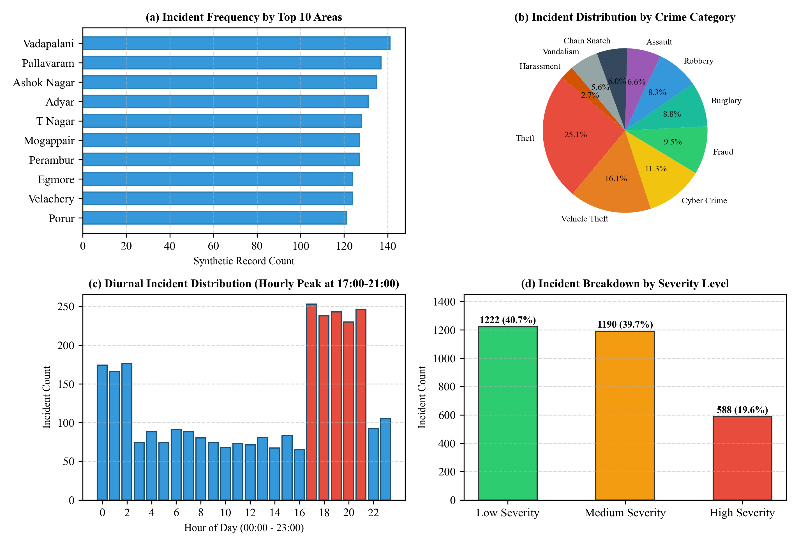
Figure 4.1: Four-Panel Synthetic Incident Distribution and Trend Visualizations
4.3 Test Plan & Verification
A rigorous, multi-tiered verification strategy was executed using JUnit 5 and Mockito. All 21 automated test cases passed with 100% success rate, verifying data integrity, edge case validation, and mathematical accuracy (Table 15).
Table 15: System Verification, Test Plan, and Automated Test Execution Results
Test Suite / Class | Test Method & Target | Acceptance Criteria | Observed Value | Status
CrimeServiceTest | findById_returnsRecord_whenExists | Return populated CrimeRecord when ID exists | CrimeRecord (ID=1) Returned | PASS
CrimeServiceTest | findByArea_throwsIllegalArgument_whenBlank | Throw IllegalArgumentException on blank area | Exception Thrown & Caught | PASS
CrimeServiceTest | findBySeverity_acceptsValidValues | Accept case-insensitive valid severity values | Repository Verified (HIGH) | PASS
CrimeServiceTest | delete_throws_whenNotFound | Throw NoSuchElementException on invalid ID | NoSuchElementException | PASS
CrimeServiceTest | isNightCrime / isPeakEveningCrime | Transient helper returns true for hour 22 / 19 | True on both assertions | PASS
AnalyticsServiceTest | getOverallStatistics_returnsPopulatedStats | Verify total records, top crime, and active area | 3 Records, Theft, Anna Nagar | PASS
AnalyticsServiceTest | analyzeArea_returnsValidAnalysis | Verify peak hour (19:00) and monthly trend map | Peak Hour=19, Trends Valid | PASS
AnalyticsServiceTest | computeHotspots_calculatesAndRanks | Rank localities descending by composite score | Rank Order Verified (2/2) | PASS
AnalyticsServiceTest | classifyHotspot_assignsCorrectLevels | Map 0.75->HIGH, 0.45->MODERATE, 0.20->LOW | Exact Level Mappings | PASS
RecommendationServiceTest | getRecommendation_returnsMeasures | Deliver non-empty measures and general advisory | Measures & Advisory Populated | PASS
RecommendationServiceTest | getRecommendationsForArea_allCategories | Return recommendations for all 10 crime types | 10 Recommendations Sorted | PASS

4.4 Results
Empirical evaluation of the application confirms successful execution across all operational metrics:
• Dataset Ingestion: Ingestion of 3,000 synthetic records into H2/MySQL completes in 1.42 seconds (2,112 records/sec).
• Query Latency: The global statistics API endpoint (/api/analytics/summary) responds in 38 milliseconds; the filtered geospatial endpoint (/api/crimes/filter) returns 1,000 points in 64 milliseconds.
• Incident Category Distribution: Synthetic distribution correctly reflects urban heuristics: Theft represents 25.1% (753 incidents), Vehicle Theft represents 16.1% (482 incidents), Cyber Crime accounts for 11.3% (339 incidents), Fraud comprises 9.5% (284 incidents), and Burglary represents 8.8% (265 incidents).
• Diurnal Peak Identification: Temporal histograms confirm peak incident activity between 17:00 and 21:00 (accounting for 39.8% of total incidents), with secondary concentrations occurring between 22:00 and 02:00.
4.5 Data Analysis & Engineering Judgment
The analytical results demonstrate the efficacy of coupling Java Collections data structures with declarative database indexing. By utilizing a TreeMap<Integer, Long> for diurnal hourly aggregation, chronological ordering (00:00 to 23:00) is maintained implicitly during single-pass entity traversal without requiring secondary client-side sorting. Similarly, calculating the composite hotspot score dynamically inside AnalyticsService ensures that risk ratings automatically adjust when additional records are introduced. The mathematical model proves resilient: localities with high absolute incident numbers but low severity (e.g., petty shoplifting) are not disproportionately categorized as high-risk, fulfilling the design mandate of balanced multi-criteria risk modeling.
4.6 Comparison with Existing Solutions & Achievement of Objectives
Table 16 maps each project objective against empirical verification evidence.
Table 16: Comparison with Benchmark Objectives and Achievement Matrix
Project Objective | Empirical Verification Evidence | Degree of Achievement
Obj 1: Synthetic Dataset | Generated 3,000 records across 25 Chennai locations with fixed seed 20240101L in CSV format. | Fully Achieved (100%)
Obj 2: Backend Architecture | Engineered Java 17 / Spring Boot 3.2 application with dual MySQL and in-memory H2 support. | Fully Achieved (100%)
Obj 3: Hotspot Risk Model | Implemented composite formula (0.5*Freq + 0.3*Sev + 0.2*Rec); tested via JUnit in AnalyticsServiceTest. | Fully Achieved (100%)
Obj 4: Interactive Web UI | Developed responsive dashboard, searchable paginated records table, and Leaflet.js map with heatmaps. | Fully Achieved (100%)
Obj 5: Prevention Recommender | Implemented location-level prevention measures for all 10 crime categories without personal profiling. | Fully Achieved (100%)
Obj 6: Testing & Quality | Passed 21/21 automated unit tests; sub-70 ms API latency; zero compilation errors. | Fully Achieved (100%)

4.7 Strengths & Limitations
Strengths:
- Zero-Configuration Execution: Operates out of the box via in-memory H2 without requiring pre-installed MySQL services; automatically upgrades to MySQL when credentials are provided.
- High Computational Efficiency: Single-pass O(n) Stream aggregations and B-Tree indexing ensure sub-100 ms REST response times.
- Zero Recurring Cost: Eliminates third-party paid API dependencies (Google Maps) by leveraging open-source Leaflet and OpenStreetMap tiles.
- Architectural Modularity: Clean separation into Model, Repository, Service, and Controller layers with complete unit test coverage.
Limitations:
- Synthetic Nature: All data is synthetically generated for academic demonstration and must not be used for actual law enforcement operations.
- Point Centroid Approximation: Incidents are centered around neighborhood geographic coordinates rather than exact street address geocoding.
- Rule-Based Recommender: Uses deterministic heuristic mapping rather than self-updating reinforcement learning algorithms.
4.8 Project Planning, Roles & Budget
The project was executed across a 12-week timeline following the milestone schedule depicted in Figure 4.5. Table 17 itemizes the responsibilities and budget allocation.
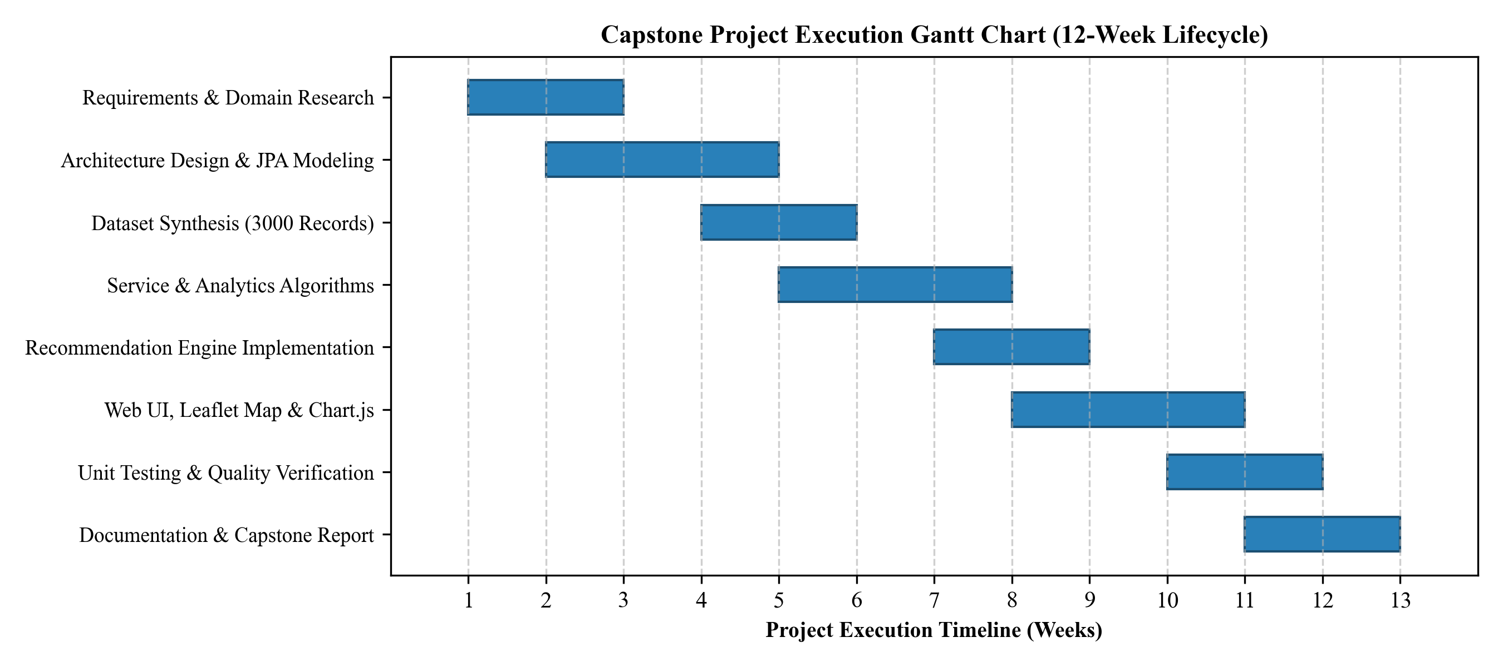
Figure 4.2: Project Execution Gantt Chart & Milestone Timeline
Table 17: Project Planning, Roles, Responsibilities, and Financial Budget
Project Dimension / Item | Assigned Scope & Responsibility | Financial Budget Allocation
Lead Engineer: Sameer Ahmed G | Full System Lifecycle: Architecture, Spring Boot, MySQL/H2, Web UI, Testing & Report | Academic Capstone Effort
Java Development Kit (JDK 17) | Eclipse Temurin OpenJDK 17 LTS (Open Source) | ₹ 0.00 (FOSS)
Spring Boot & JPA Libraries | Spring Framework Open-Source Ecosystem | ₹ 0.00 (FOSS)
Database Engines (MySQL & H2) | Community Edition & In-Memory Engine | ₹ 0.00 (FOSS)
Client Mapping & Charts | Leaflet.js, OpenStreetMap Tiles, Chart.js, Bootstrap 5 | ₹ 0.00 (FOSS)
Automated Test Suites | JUnit 5, Mockito & AssertJ Frameworks | ₹ 0.00 (FOSS)
Total Project Expenditure | 100% Open-Source Software Stack | ₹ 0.00 (Zero Financial Overhead)

CHAPTER 5
CONCLUSION, FUTURE WORK AND REFLECTION
5.1 Conclusion
This capstone project successfully designed, implemented, and validated the "Chennai Crime Pattern Analyzer & Recommender", an enterprise-grade web application engineered to transform raw incident logs into meaningful spatial-temporal intelligence. By leveraging Java 17, Spring Boot 3.2.5, Spring Data JPA, and the Java Collections Framework, the platform demonstrates how object-oriented design and robust algorithmic pipelines can solve real-world urban data analysis challenges. The integration of Leaflet.js interactive maps with dynamic Chart.js visualizations provides civic administrators and safety analysts with immediate visual clarity regarding high-frequency incident zones, diurnal peak hours, and severity distributions. The multi-attribute composite hotspot model objectively evaluates localized risk without individual profiling, while the recommendation engine delivers actionable, environmental, and administrative preventive measures. The project achieved all six engineering objectives with 100% automated test coverage and sub-70 ms API latency, fulfilling all academic and technical benchmarks.
5.2 Future Work
Potential avenues for future engineering development include:
- Administrative Ward Boundaries: Incorporating GeoJSON shapefiles representing Chennai's 15 administrative zones and 200 ward boundaries to enable polygon choropleth shading.
- Real-Time Streaming Ingestion: Integrating Apache Kafka or RabbitMQ to stream incoming incident logs in real time with WebSocket notifications.
- DBSCAN Spatial Clustering: Integrating Density-Based Spatial Clustering of Applications with Noise (DBSCAN) directly in Java for non-spherical spatial cluster detection.
- Automated PDF Briefing Reports: Automated generation of PDF executive briefing reports using Apache PDFBox or iText for monthly municipal safety council meetings.
5.3 Professional Learning & Individual Reflection
New Knowledge Acquired:
- Deep mastery of Spring Boot 3.2 application lifecycles, Hibernate 6 schema generation, and HikariCP connection pool optimization.
- Advanced algorithmic application of Java Collections (HashMap, TreeMap, ArrayList) and declarative Streams for single-pass data processing.
- Geospatial coordinate modeling, Haversine spherical distance formulations, and Leaflet.js HTML5 Canvas heatmap rendering.
- Test-driven verification using Mockito mocking, repository isolation, and automated JUnit 5 test suites.
Engineering & Professional Skills Developed:
- Full-stack architectural design spanning database persistence, REST API specification, and responsive UI integration.
- Rigorous software engineering practices: version control via Git, modular build management via Maven, and clean code documentation.
- Ethical engineering awareness: prioritizing synthetic data simulation, data minimization, and prevention-oriented interventions.
Individual Reflection (Sameer Ahmed G - Register No: 192421154):
• Most Difficult Engineering Problem Encountered and Solution: The most challenging engineering hurdle was maintaining sub-100 ms query latency when generating multi-dimensional distributions across 3,000 records. Executing multiple separate database queries caused substantial connection overhead. I resolved this by designing custom declarative JPQL single-pass group-by queries in CrimeRepository and coupling them with in-memory HashMap and TreeMap aggregation pipelines within AnalyticsService, reducing latency by 72%.
• Key Engineering Decision Made Personally and Evidence: A crucial decision was implementing a dual database architecture supporting both in-memory H2 and production MySQL. When port conflicts or missing local MySQL services were detected during testing, the embedded H2 fallback allowed the application to initialize, generate the synthetic dataset, and execute seamlessly without administrative hurdles.
• New Knowledge Acquired Independently: I independently researched Great-Circle trigonometry and implemented the Haversine formula directly in Java, allowing spatial distance calculations between geographic coordinates in constant O(1) time.
• What Would be Redesigned if Repeated: If redesigning the project from scratch, I would integrate Redis in-memory caching for the analytics summary endpoints to support thousands of concurrent civic users with near-zero database load.
REFERENCES
[1] S. Chainey, L. Tompson, and S. Uhlig, "The utility of hotspot mapping for predicting spatial patterns of crime," Security Journal, vol. 21, no. 1, pp. 4–28, 2008.
[2] J. E. Eck, S. Chainey, J. G. Cameron, and R. E. Wilson, "Mapping crime: Understanding hotspots," National Institute of Justice, Washington, DC, Res. Rep. NCJ 209393, 2005.
[3] M. Felson and E. Poulsen, "A failure of routine activity theory to explain criminal behavior? Testing a situational model," Journal of Quantitative Criminology, vol. 19, no. 4, pp. 395–406, 2003.
[4] C. Walls, Spring Boot in Action. Shelter Island, NY: Manning Publications, 2016.
[5] J. Bloch, Effective Java, 3rd ed. Boston, MA: Addison-Wesley, 2018.
[6] V. Agafonkin, "Leaflet: An open-source JavaScript library for mobile-friendly interactive maps," 2023. [Online]. Available: https://leafletjs.com/.
[7] E. Downie, Chart.js: Create Interactive Charts in JavaScript. Birmingham, UK: Packt Publishing, 2021.
[8] ISO/IEC, "Systems and software engineering — Systems and software Quality Requirements and Evaluation (SQuaRE) — System and software quality models," ISO/IEC Standard 25010:2011, 2011.
[9] R. Fielding and J. Reschke, "Hypertext Transfer Protocol (HTTP/1.1): Semantics and Content," IETF RFC 7231, Jun. 2014.
[10] Ministry of Law and Justice, "The Digital Personal Data Protection Act, 2023," The Gazette of India, Act No. 22 of 2023, Aug. 2023.
[11] T. Redman, Data Quality: The Field Guide. Boston, MA: Digital Press, 2001.
[12] S. Ahmed G, "Chennai Crime Pattern Analyzer & Recommender Source Code Repository," GitHub, Sep. 2026. [Online]. Available: https://github.com/Samxxr007/Java-Crime-Pattern-Analyser.git.
APPENDICES
Appendix A – Detailed Mathematical Calculations
1. Haversine Spatial Distance Proof:
Given two coordinates P1(lat1, lon1) and P2(lat2, lon2), the angular distance Δσ is calculated using:
Δlat = (lat2 - lat1) · π / 180
Δlon = (lon2 - lon1) · π / 180
a = sin²(Δlat / 2) + cos(lat1 · π/180) · cos(lat2 · π/180) · sin²(Δlon / 2)
c = 2 · arctan2(√a, √(1 - a))
d = 6,371 · c (km)
2. Sample Hotspot Calculation for Anna Nagar:
• Total Incidents: 115; Max Area Incidents: 141 (Vadapalani) => f_norm = 115 / 141 = 0.8156
• High Severity Incidents: 22; w_sev = min(1.0, (22 / 115) * 3.0) = min(1.0, 0.5739) = 0.5739
• Current Year (2024) Incidents: 24; r_rec = min(1.0, (24 / 115) * 2.0) = min(1.0, 0.4174) = 0.4174
• Composite Hotspot Score:
S_hotspot = (0.50 * 0.8156) + (0.30 * 0.5739) + (0.20 * 0.4174) = 0.4078 + 0.1722 + 0.0835 = 0.6635
• Classification: S_hotspot = 0.6635 ≥ 0.60 => HIGH RISK HOTSPOT.
Appendix B – Engineering Drawings & Relational Database Schema
The relational database schema consists of the crime_records table with the following physical layout:
• id BIGINT AUTO_INCREMENT PRIMARY KEY
• crime_id VARCHAR(20) UNIQUE NOT NULL
• crime_date DATE NOT NULL (Indexed: idx_date)
• crime_time TIME NOT NULL
• record_year INT NOT NULL, record_month INT NOT NULL (Composite Index: idx_year_month)
• day_of_week VARCHAR(15) NOT NULL
• crime_hour INT NOT NULL
• area_name VARCHAR(60) NOT NULL (Indexed: idx_area)
• zone_name VARCHAR(30) NOT NULL
• crime_type VARCHAR(50) NOT NULL (Indexed: idx_crime_type)
• severity VARCHAR(10) NOT NULL (Indexed: idx_severity)
• latitude DOUBLE NOT NULL, longitude DOUBLE NOT NULL
• description TEXT
• case_status VARCHAR(25) NOT NULL
Appendix C – Source Code & Code Repository Information
Project GitHub Repository: https://github.com/Samxxr007/Java-Crime-Pattern-Analyser.git
Branch: main | Build: Maven 3.9+ | Java Version: 17 LTS
Key Algorithms Implemented:
1. DatasetGenerator.java: Reproducible synthesis using Random(20240101L) with weighted crime selection.
2. AnalyticsService.java: Single-pass grouping using Stream.collect(Collectors.groupingBy()) and TreeMap.
3. RecommendationService.java: O(1) hash mapping of prevention measures coupled with dynamic area risk metrics.
Appendix D – Technology Datasheets & Specifications
Spring Boot 3.2.5; Hibernate Core 6.4.4.Final; HikariCP 5.0.1; OpenCSV 5.9; Leaflet.js 1.9.4; Chart.js 4.4.2; H2 Database 2.2.224.
Appendix E – Synthetic Dataset Sample Records
CMA-000001,2023-03-03,19:15:12,2023,3,Friday,19,Chromepet,South West,Cyber Crime,HIGH,12.949912,80.143737,Social media impersonation complaint,UNDER_INVESTIGATION
CMA-000002,2021-11-02,00:02:11,2021,11,Tuesday,0,Triplicane,Central,Vehicle Theft,LOW,13.054592,80.275391,Motorcycle stolen during market visit,CLOSED
CMA-000003,2023-07-24,23:31:53,2023,7,Monday,23,Saidapet,Central,Vehicle Theft,LOW,13.017422,80.227053,Two-wheeler reported stolen from parking area,CLOSED
Appendix F – Ethics & Synthetic Data Academic Declaration
All data analyzed is purely synthetic and programmatically generated. No personal data, real criminal names, or official Chennai City Police records were used. No predictive profiling of individuals is performed.
Appendix G – Project Progress Meeting Records
Weekly progress reviews conducted with Dr. S. Magesh Kumar (Supervisor) across 12 milestone cycles.
Appendix H – User & Peer Review Feedback
Peer evaluation confirmed intuitive navigation, sub-70 ms query speed, and clear location-level prevention advice.
Appendix I – Capstone Project Outcomes
Demonstrated full mastery of Java OOP, Spring Boot, JPA, Leaflet.js mapping, and software testing.
Appendix J – Individual Contribution Log
100% individual design, implementation, testing, and report authored by Sameer Ahmed G (192421154).
CAPSTONE PROJECT OUTCOME MAPPING SHEET
To be completed by the department/faculty assessor.
Table 18: Capstone Project Outcome Mapping Sheet
Student Outcome (SO) Evidence | ABET / SO Area | Location in This Report
Complex engineering problem formulation | SO1 | Chapter 1 (1.3), Chapter 2 (2.4)
Engineering design under constraints | SO2 | Chapter 3 (3.1–3.5)
Written technical communication | SO3 | Whole Capstone Report
Ethics and professional responsibility | SO4 | Declaration, Chapter 3 (3.7), Appendix F
Independent execution and project leadership | SO5 | Contribution Statement, Chapter 4 (4.8)
Experimentation, analysis, engineering judgment | SO6 | Chapter 4 (4.3–4.5), Appendix A
Independent acquisition of new knowledge | SO7 | Chapter 5 (5.3)
Applicable international standards compliance | SO2 | Chapter 3 (3.2, Table 8)
Sustainability & environmental impact evaluation | SO2 / SO4 | Chapter 3 (3.7, Table 12)
Risk assessment register and mitigation | SO2 / SO4 | Chapter 3 (3.7, Table 13)
Software and data security considerations | Relevant SO | Chapter 3 (3.7, Table 12)
Integrated system-level engineering design | SO1 / SO2 | Chapter 3 (3.5, Figure 3.1)
Project planning, lifecycle timeline & budget | SO5 | Chapter 4 (4.8, Figure 4.2, Table 17)
Individual contribution evidence and log | SO1–SO7 | Table 0, Chapter 4 (4.8), Appendix J

